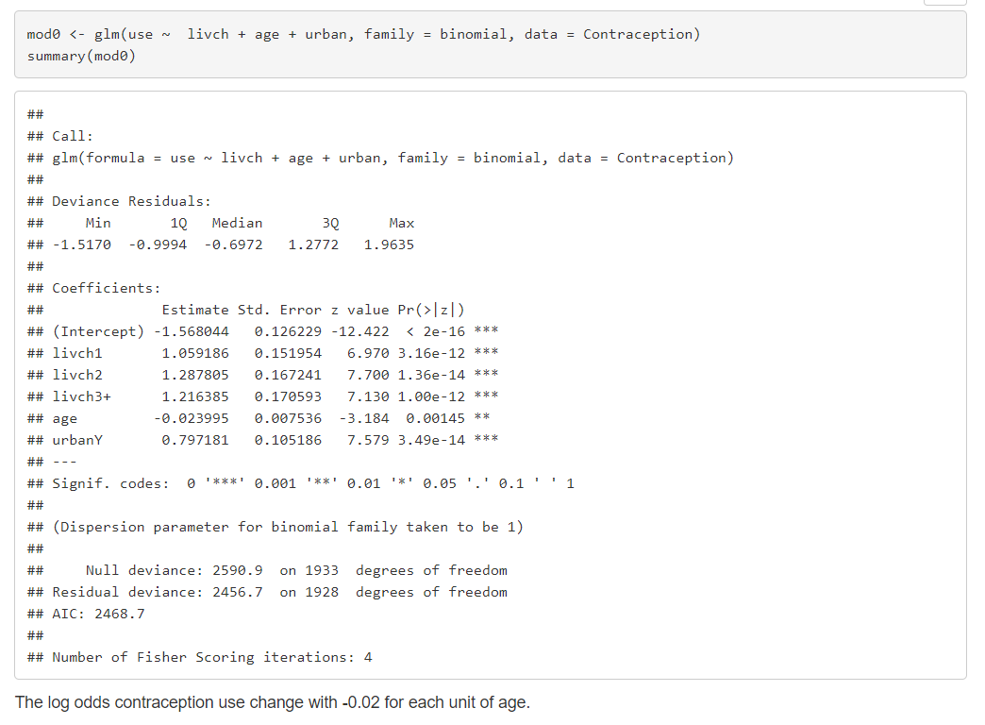**Mixed models exercises part 4**

Because age didn’t seem to have a linear relation on the use of contraception we tried the same model with age as a quadratic component.

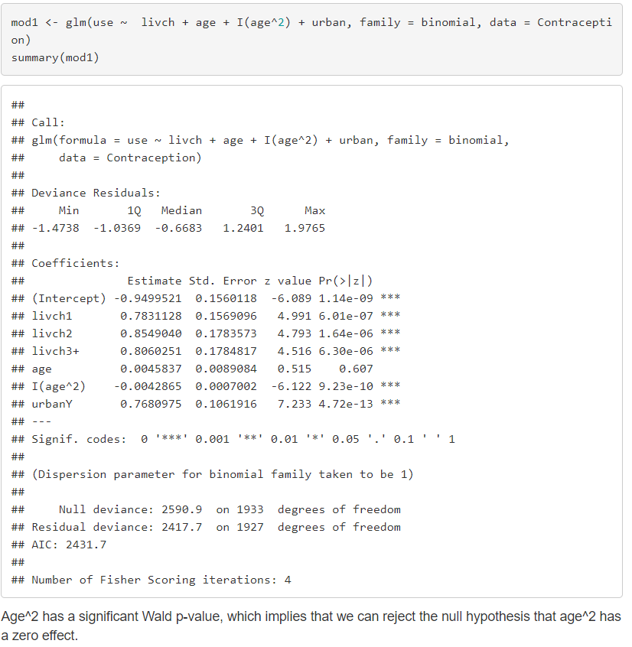

Family = binomial because dichotomic (contraception or not)

Logistic model for contraception regressed on main effects of livch, age and urban with quadratic component for age l(age^2)

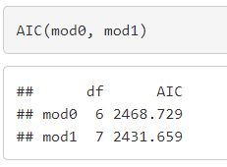based on AIC we would want to use mod1 as it is smaller – quadratic effect of age makes model better

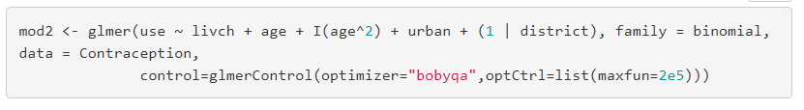then we added a **random intercept** for district as we expect variance of contraceptive use in the districts

then again compared the AIC between mod1 and mod2. AIC was smaller for mod2 -> preferable

One can compare the models with likelihood ratio test.

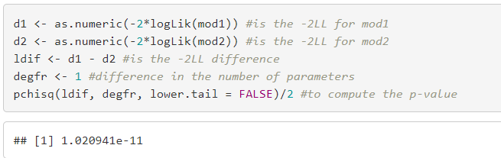

The p-value is divided by two because the **extra parameter of mod2 by adding the random intercept for each district** - is a variance parameter which can only be positive, so we want to test one-sidedly. degfr is one because **mod2 has one extra parameter**. The -2LL of mod2 is significantly closer to 0 (p = 1.02e-11 << 0.05), therefore mod2 is preferable.

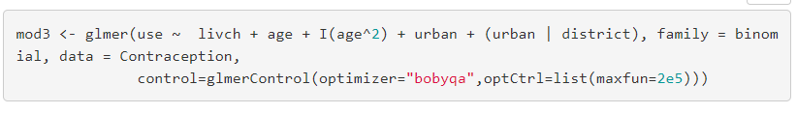Model 3 we added a random slope for urban. So now it has random intercept for district and random slope for urban.

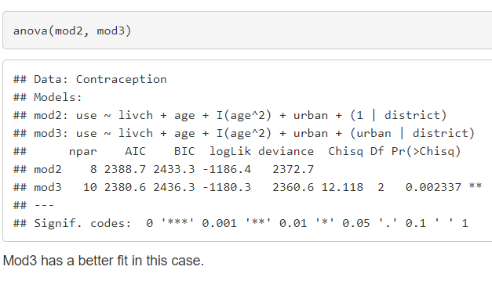

Then an ANOVA to compare the models

Shows that AIC smaller for mod3 -> better fit

**Exercise 2**

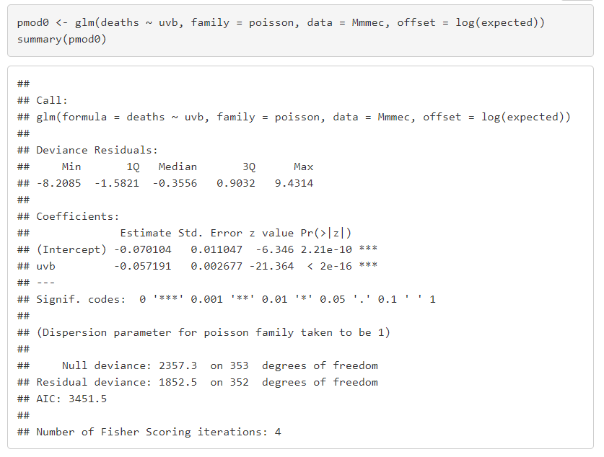Poisson regression model for deaths, regressed on a main effect of uvb.

Poisson because it is a COUNT of deaths.

The linear effect of UVB seems to be negative.

Now we add a random intercept for region with glmer

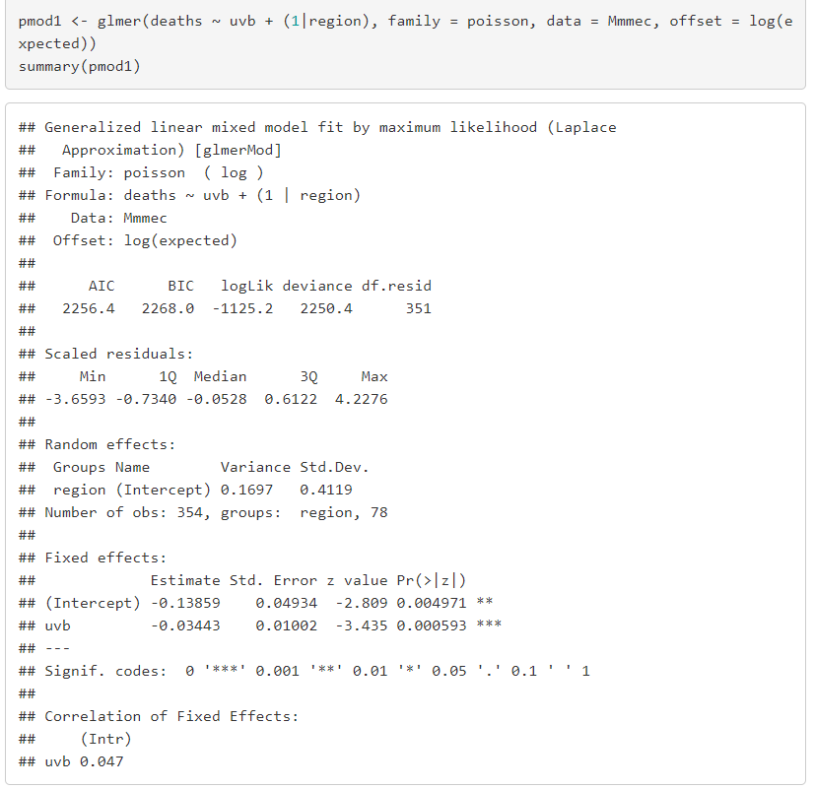

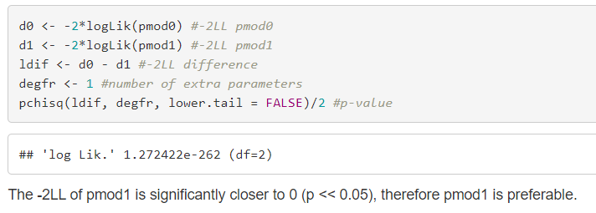Effect of UVB still seems to be negative. When comparing AIC of the models pmod1 was still much smaller and therefore preferred but now we’ll test which one is preferred with maximum log likelihood.

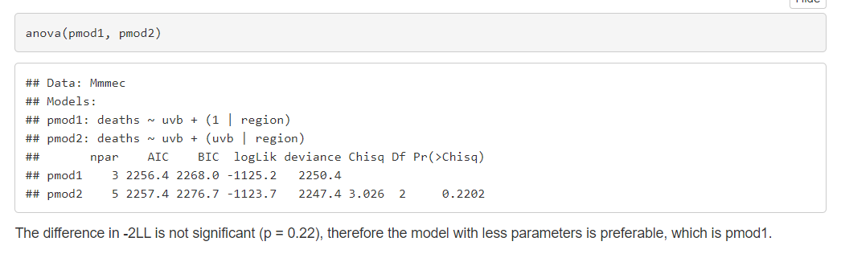when deciding on model by using -2LL check for significance and decide on number of parameters if not significant. Smaller -2LL is better.

If it’s significant we should use the one with more parameters